Running kmeans for K=2 ...

K=2: MSE=493.96, PSNR=21.19 dB, bpp_fixed=0.0625, bpp_entropy=0.0578
Running kmeans for K=4 ...

K=4: MSE=171.75, PSNR=25.78 dB, bpp_fixed=0.1250, bpp_entropy=0.1131
Running kmeans for K=8 ...

K=8: MSE=58.64, PSNR=30.45 dB, bpp_fixed=0.1875, bpp_entropy=0.1726
Running kmeans for K=16 ...

K=16: MSE=26.67, PSNR=33.87 dB, bpp_fixed=0.2500, bpp_entropy=0.2179
Running kmeans for K=32 ...

K=32: MSE=16.23, PSNR=36.03 dB, bpp_fixed=0.3125, bpp_entropy=0.2755
Running kmeans for K=64 ...
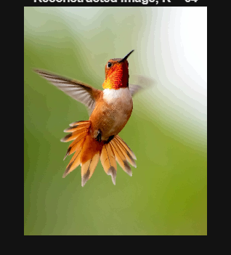
K=64: MSE=11.75, PSNR=37.43 dB, bpp_fixed=0.3750, bpp_entropy=0.3047

